MYSQL WITH JDBC CONNECTION
Database :employee1
Table : emp

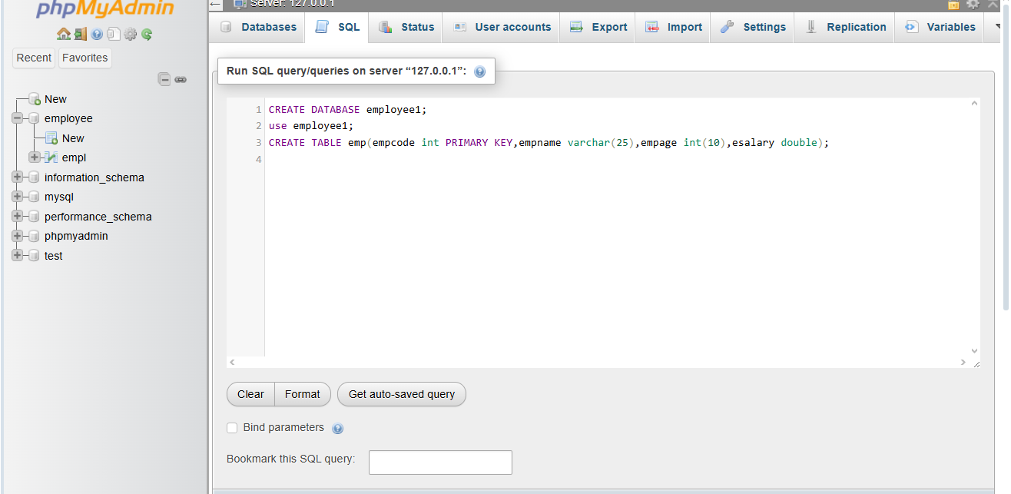
Empty emp table:
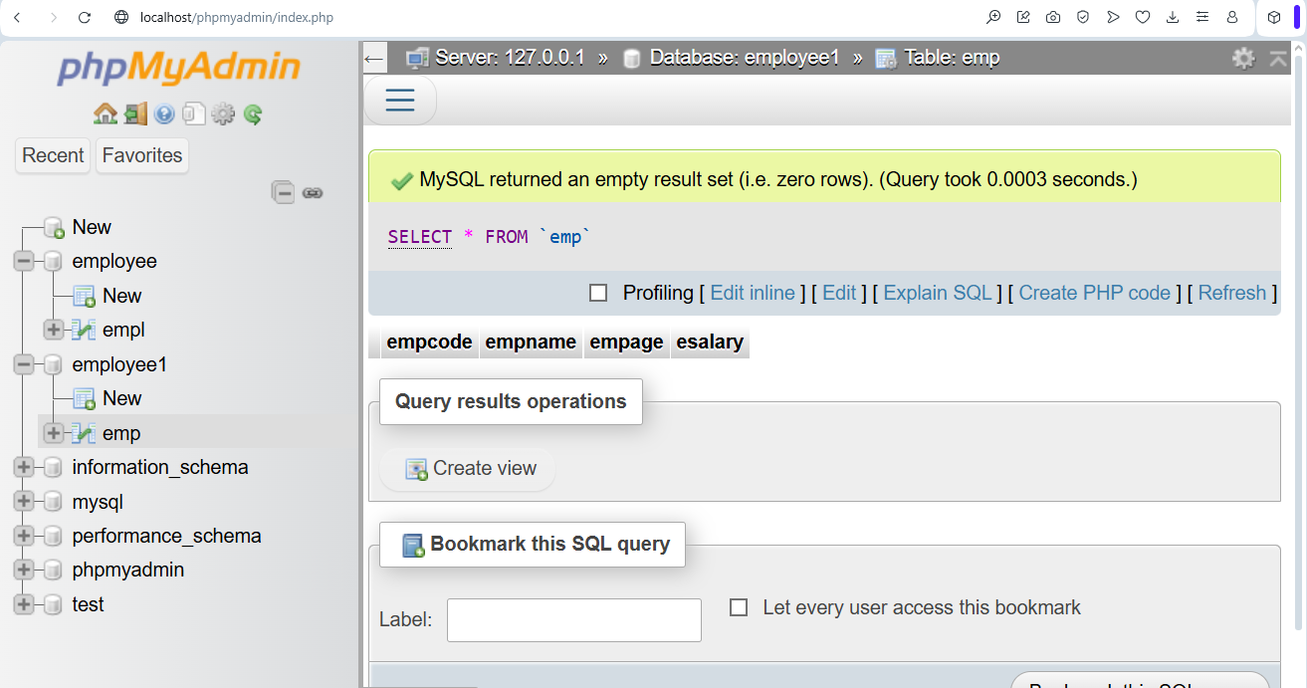

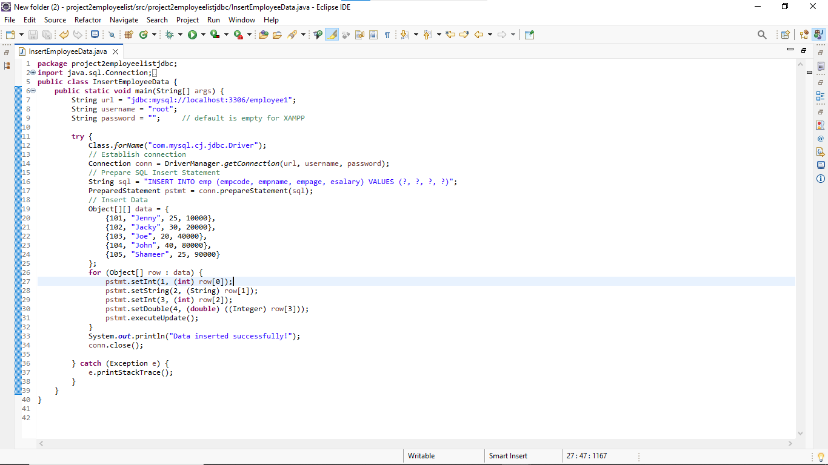
Java program (JDBC CONNECTIVITY) in eclipse

If I run the programThe output is “Data inserted successfully”
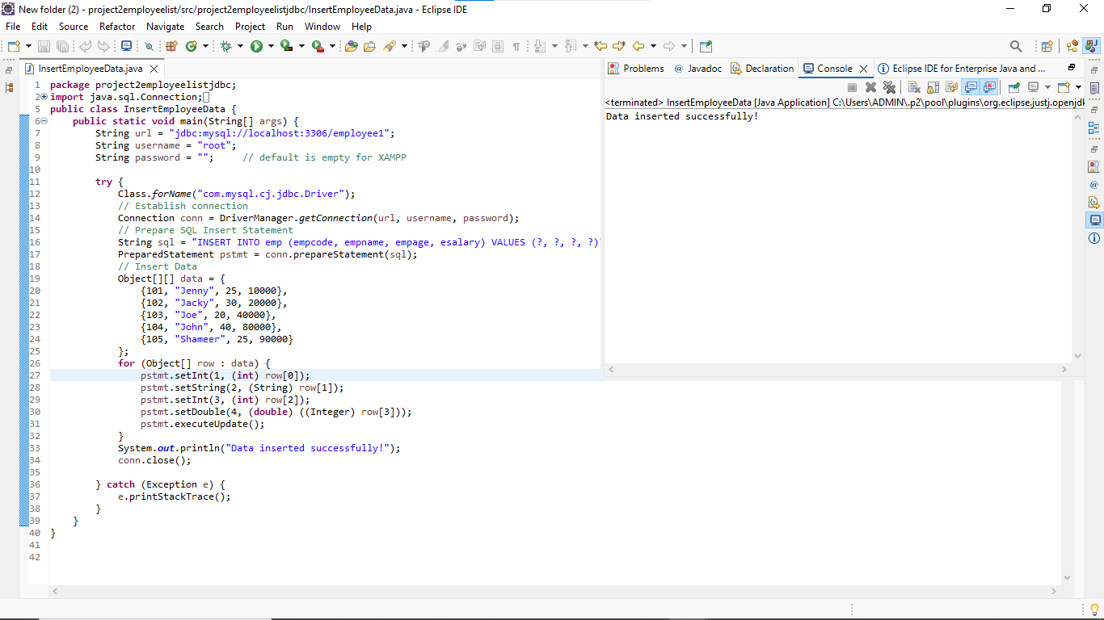

The output in XAMPP
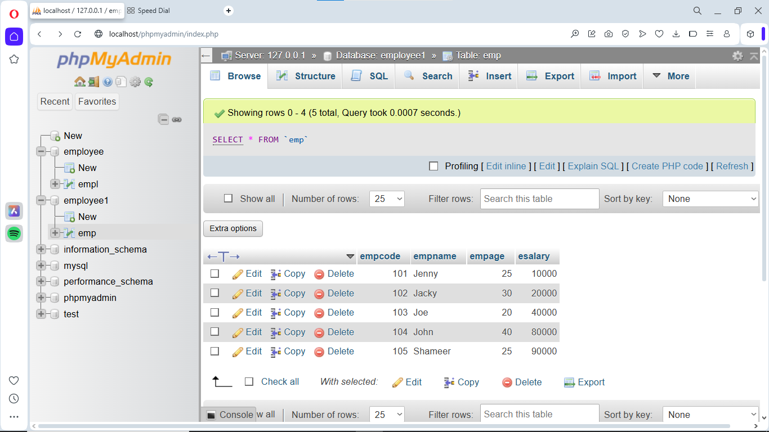

JAVA CODE:
package project2employeelistjdbc;
import java.sql.Connection;
import java.sql.DriverManager;
import java.sql.PreparedStatement;
public class InsertEmployeeData {
public static void main(String[] args) {
String url = "jdbc:mysql://localhost:3306/employee1";
String username = "root";
String password = ""; // default is empty for XAMPP

try {
Class.forName("com.mysql.cj.jdbc.Driver");
// Establish connection
Connection conn = DriverManager.getConnection(url, username, password);
// Prepare SQL Insert Statement
String sql = "INSERT INTO emp (empcode, empname, empage, esalary) VALUES (?, ?, ?, ?)";
PreparedStatement pstmt = conn.prepareStatement(sql);
// Insert Data
Object[][] data = {
{101, "Jenny", 25, 10000},
{102, "Jacky", 30, 20000},
{103, "Joe", 20, 40000},
{104, "John", 40, 80000},
{105, "Shameer", 25, 90000}
};
for (Object[] row : data) {
pstmt.setInt(1, (int) row[0]);
pstmt.setString(2, (String) row[1]);
pstmt.setInt(3, (int) row[2]);
pstmt.setDouble(4, (double) ((Integer) row[3]));
pstmt.executeUpdate();
}
System.out.println("Data inserted successfully!");
conn.close();

} catch (Exception e) {
e.printStackTrace();
}
}
}

